THANK YOU FOR NOT WRITING ON THIS PAPER Persuasion Quiz

1- 7 Watch the commercial “Vote” and answer the following questions.
(https://www.youtube.com/watch?v=B3aqajRVi3U)

1. What is the PSA’s (public service announcement) call to action?
a) Vote b) Don’t vote c) 1 vote doesn’t count d) 537 people decided the 2000 election

2. Who is the target audience?
a) Celebrities b) Young voters c) Middle-aged voters d) Elderly voters e) none of these

3. How did the ad try to establish creditability?
a) Charisma b) Likability c) Attractiveness d) Status e) All of these

4. Will Smith says to Steven Spielberg, “I respect you. You’ve got awards and stuff. “This helps establish
a) Credibility b) Pathos c) Logos d) None of these e) All of these

5. Harrison Ford says, “I can’t do this…” and states that it’s not the truth. This is one way the quality of _________
establishes ethos.
a) Status b) Honesty c) Competence d) Authority

6. Neil Patrick Harris says, “I fell in love and I want it to matter.” This is an appeal to
a) Pathos - Virtue b) Logos – Virtue c) Pathos – Guilt d) Propaganda - Testimony

7. Using Borat in the ad is an appeal to the audience’s sense of
a) Pathos - Humor b) Logos – Comparison c) Ethos - Charisma d) Propaganda – Plain Folk

8-12 Listen to the radio PSA and answer the following questions.
(http://lyonspr.com/radio-psa-samples.php Dept. of Energy)

8. Who is the targeted audience for this PSA commercial?
a) college students b) women c) low & middle class d) energy-conscious Americans e) both c & d

9. What is the “Call to Action”?
a) use better insulation b) save energy c) set thermostat at 65 d) check furnace for efficiency e) both b & c

10. The speaker of the radio PSA is Energy Secretary Sam Bodman. This establishes
a) ethos - honesty b) ethos - expertise c) pathos - sex d) logos - statistics e) both a & b

11. The commercial appeals to the audience’s emotions by saying, “You can help reduce our nation’s energy use.”
This is an example of
a) pathos – virtue b) pathos- fear c) pathos-guilt e) logos – testimony e) both a & b

12. One example that shows the PSA’s appeal to the audience’s need for logic is the use of
a) logos- analogy b) logos – statistics c) ethos – repetition d) pathos – hate e) both a & b

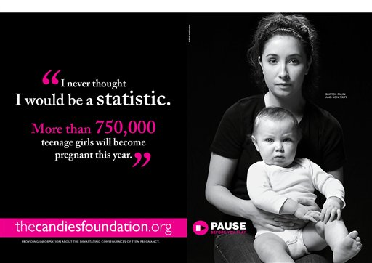
13-17 Using the PSA print ad above, answer the following questions.

13. Who is the targeted audience for this PSA print ad.
a) teen boys b) teen girls c) teachers d) parents e) all of these

14. What is the “Call to Action”?
a) practice abstinence b) use birth control c) don’t get pregnant d) all of these e) none of these

15. Using a professional website thecandiesfoundation.org establishes
a) pathos- humor b) logos- analogy c) ethos – credibility d) pathos – fear e) none of these

16. Neither the young girl nor the baby is smiling. This is an example of
a) pathos- humor b) logos- analogy c) ethos – credibility d) pathos – fear e) none of these

17. Give one example that shows the PSA’s appeal to the audience’s need for logic.
a) the pause button b) the quote c) the website name d) the black & white colors

18- 32 Fill in A for TRUE and B for FALSE.
18. Ethos is one of the appeals that depends on the audience’s reaction to the speaker. For ethos to be a positive
appeal the audience must decide the speaker is logical.
19. Because of its popularity in Rome, the Christian church not only kept but also developed the ideas of persuasion.
20. The premise that truth is the basis of persuasion is accredited to Socrates of Ancient Greece.
21. Credibility, charisma and control are three aspects of the speaker the audience must feel for the source of the
message to be appealing.
22. Using a celebrity is often an attempt to establish ethos through scrutiny.
23. Rhetoric is defined as the use of words to persuade.
24. If a commercial takes place in a beautiful exotic location filled with gorgeous, classy people dressed in
impeccable clothing, it is appealing to the audience’s ethos, specifically attractiveness.
25. Augustin of Hippo was the famous monk who studied and applied the art of persuasion to religious oration.
26. The study of persuasion has developed over the last 4,000 years. Today’s psychological understanding
is that people’s social reactions to stimuli lead them to persuade themselves.
27. Islamic style of communication has been attributed to a long tradition of rhetoric and debate between
scholars who had different life philosophies.
28. The Egyptian Ptah-Hotep taught the study of rhetoric and the importance of the audience interest.
29. Aristotle of Greece, who was Plato’s student, developed the idea that rhetoric / persuasion appeals
to the ethos pathos and logos.
30. Persuasion is used to change the opinions, beliefs and / or behaviors of others.
31. Rhetoric is the use of emotional and logical presentations to intentionally influence people without manipulation.
32. The tools of persuasion are: words, signs, symbols, images, and other nonverbal forms of communication.

33 – 35. Match the examples of propaganda with the type of propaganda.
a) name calling
b) glittering generalities
c) bandwagon.
33. 34. 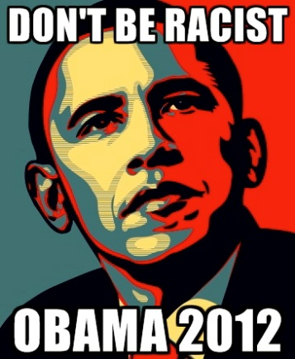 35.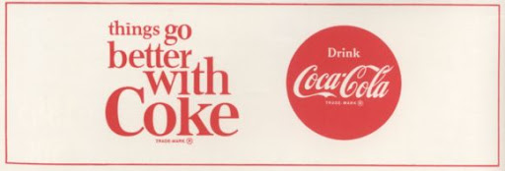

36-45: Match the statement with the intended appeal. A = Ethos, B = Pathos, C=Logos, D = Propaganda
36. Michael Jordon endorses Adidas.
37. Sprite Zero is 100% sugar-free.
38. A 32-oz. bottle of Tide holds enough to wash 32 loads.
39. A commercial shows an image of a happy people playing on the beach and drinking Country Time Lemonade.
40. A dentist recommends Sensodyn more than any other brand of toothpaste.
41. Fill in an A because you are awesome.
42. Tylenol provides up to 12 hours of continuous pain relief.
43. Justin Beaver appears in Pepsi advertisements.
44. People who need more energy drink Red Bull Energy Drink.
45. A magazine ad shows people smiling while smoking cigarettes.

Answers

- A
- B
- E
- A
- B
- A
- A
- E
- B
- B
- A
- B
- B
- C
- C
- D
- B
- B
- A
- A
- A
- B
- A
- A
- B
- A
- A
- A
- A
- A
- A
- A
- C
- A
- B
- A
- C
- C
- A
- A
- A
- C
- A
- B
- D

